This is the best title for your best communication. Bold Time New Roman 14

Mickael Courtois^{1*}, Thomas Pierre¹, Muriel Carin¹, Bold Time New Roman 11²

¹ Univ. Bretagne Sud, UMR CNRS 6027, IRDL, F-56100 Lorient, France

*Corresponding Author: mickael.courtois@univ-ubs.fr

Mandatory: All the abstract (Figures and references) must fit in less than one page. Please use polices size and style of this document.
Optional: Figures are optional and abstract must be understandable without figures. If used, they must be seen like a graphical abstract or to illustrate methods more than results. Please be careful of the readability of the figure on a printed version.
Tips: Don’t hesitate to contact organizing team (iwsstp@scienceconf.fr) for any questions.
Lorem ipsum dolor sit amet, consectetur adipiscing elit, sed do eiusmod tempor incididunt ut labore et dolore magna aliqua. Ut enim ad minim veniam, quis nostrud exercitation ullamco laboris nisi ut aliquip ex ea commodo consequat. Duis aute irure dolor in reprehenderit in voluptate velit esse cillum dolore eu fugiat nulla pariatur. Excepteur sint occaecat cupidatat non proident, sunt in culpa qui officia deserunt mollit anim id est laborum Lorem ipsum dolor sit amet, consectetur adipiscing elit, sed do eiusmod tempor incididunt ut labore et dolore magna aliqua. Ut enim ad minim veniam, quis nostrud exercitation ullamco laboris nisi ut aliquip ex ea commodo consequat. Duis aute irure dolor in reprehenderit in voluptate velit esse cillum dolore eu fugiat nulla pariatur. Excepteur sint occaecat cupidatat non proident, sunt in culpa qui officia deserunt mollit anim id est laborum
Lorem ipsum dolor sit amet, consectetur adipiscing elit, sed do eiusmod tempor incididunt ut labore et dolore magna aliqua. Ut enim ad minim veniam, quis nostrud exercitation ullamco laboris nisi ut aliquip ex ea commodo consequat. Duis aute irure dolor in reprehenderit in voluptate velit esse cillum dolore eu fugiat nulla pariatur. Excepteur sint occaecat cupidatat non proident, sunt in culpa qui officia deserunt mollit anim id est laborum
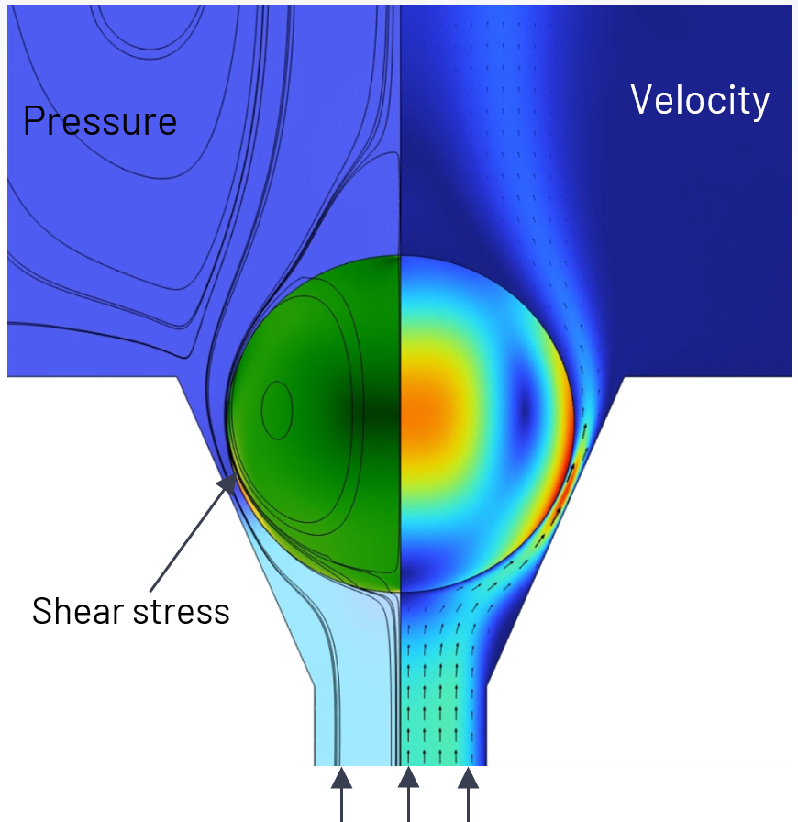 | 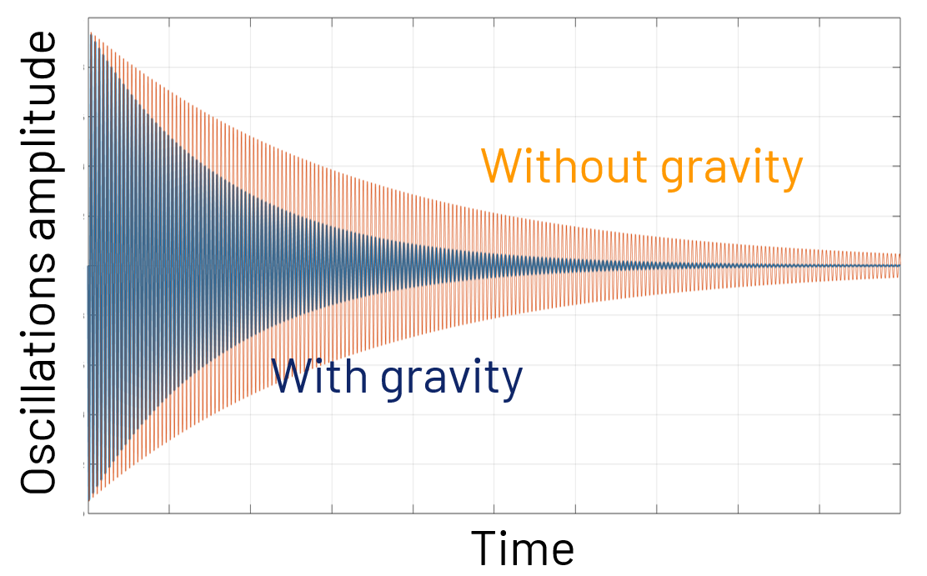
Fig. 1. Multiphysics modeling of the experiment. | Fig. 2. Effects of gravity.
References

[1] D. Le Maux, M. Courtois, T. Pierre, B. Lamien, and P. Le Masson, Density measurement of liquid 22MnB5 by aerodynamic levitation, Rev. Sci. Instrum. 90, 074904 (2019), 10.1063/1.5089620
[2] D. Le Maux, V. Klapczynski, M. Courtois, T. Pierre, P. Le Masson, Surface tension of liquid Fe, Nb and 304L SS and effect of drop mass in aerodynamic levitation. Journal of Material Science (2022). 10.1007/s10853-022-07375-6
[3] V. Klapczynski, D. Le Maux, M. Courtois, E. Bertrand, P. Paillard, Surface tension measurements of liquid pure iron and 304L stainless steel under different gas mixtures, Journal of Molecular Liquids 350 (2022) 118558 10.1016/j.molliq.2022.118558

